
Department of Computer Science &
Information Technology

University of Sargodha

Project:

MDCAT Quiz Application

Project Supervisor:

Prof. Fateh Hayat

Submitted By:

Bisma Saeed
Nimra Fatima
Khadija Malik

STATEMENT OF SUBMISSION

This is the certifying that Bisma Saeed Roll No: 21BSIT30243 Nimra Fatima Roll No: 20BSIT29943, Khadija Malik Roll No: 21BSIT30244 have successfully completed their final year project named as “MDCAT Quiz Application”, at the Department of Computer Science &Information Technology, Superior College Sargodha, to fulfill the requirement of degree of the BSIT.

Prof. Fateh Hayat Prof. Fateh Hayat
Project Supervisor HOD CS & IT
Superior College Sargodha

ACKNOWLEDGMENT

All praises for Allah Almighty, the most gracious, the most Merciful and the sustainer for all creations.
All respect to Holy Prophet Muhammad (PBUH) who enabled us to recognize our creator.
We truly acknowledge the cooperation and help make by Prof. Fateh Hayat, Department of Computer Science & Information Technology, and University of Sargodha. He has been a constant source of guidance throughout the course of this project.
We are obliged to express our thanks to all the teachers of Dept. of CS & IT department whose moral encouragement paved our way towards the accomplishment of our project. We are also thankful to our friends and family whose silent support led us to complete our project.

ABSTRACT
The MDCAT Quiz Application is a user-friendly, interactive software system designed to assist students in preparing for the Medical and Dental College Admission Test (MDCAT). The primary objective of the application is to provide an efficient platform where students can practice topic-wise multiple-choice questions (MCQs), receive instant feedback, and track their academic performance over time.
This application allows students to register, log in, select subjects and chapters, attempt quizzes, and view detailed results. The system is managed by an admin who maintains the question bank, monitors user activity, and updates quiz content as needed. Features like random question generation, result evaluation, performance analysis, and secure authentication make the application effective and reliable.
It follows both object-oriented and structured design approaches. Tools like DFD, ERDs, and state diagrams are used for development. The app improves exam preparation through smart practice and result analysis. It is user-friendly, secure, and scalable for future needs.

DEDICATION

For telling us, what we Capable of for giving us the support that we needed to build a dream to Chase after. In addition, for believing that we have the talent to reach our goals. We dedicated this humble effort to our ------Respected Parents and Teachers-------With love and respect May Allah bless them healthy life (Ameen)

Table of Contents:

CHAPTER 1: FINAL PROJECT PROPOSAL……………...……….1

INTRODUCTION…………………………………...…...………........………….1
  - PROJECT TITLE…………………………………………….….…….……....….1
  - PROJECT OVERVIEW STATEMENT…………………….….…………....…...1
  - PROJECT GOALS & OBJECTIVES………………………….…….………...…3
  - HIGH- LEVEL SYSTEM COMPONENTS……………………...…………....…3
  - LIST OF OPTIONAL FUNCTIONAL UNITS………………. ….….…......…....4
  - EXCLUSIONS........................................................................................................4
  - APPLICATION ARCHITECTURE.......................................................................4
  - GANTT CHART.....................................................................................................4
  - HARDWARE AND SOFTWARE SPECIFICATION.....................................5
  - TOOLS AND TECHNOLOGIES USED WITH REASONING......................6

CHAPTER 2: FIRST DELIVERABLE.................................................7

2.1 INTRODUCTION...................................................................................................7
2.2 PROJECT/PRODUCT FEASIBILITY REPORT...................................................7
2.2.1 Technical feasibility..........................................................................................7
2.2.2 Operational feasibility.......................................................................................7
2.2.3 Economic feasibility........................................................................................7
2.2.4 Schedule feasibility..........................................................................................8
2.2.5 Specification feasibility....................................................................................8
2.2.6 Motivational feasibility.....................................................................................8
2.2.7 Legal & Ethical feasibility................................................................................8
2.3 PROJECT/PRODUCT SCOPE................................................................................8
2.4 PROJECT/PRODUCT COSTING...........................................................................8
2.4.1 Project Cost Estimation by Function Point Analysis........................................8
2.4.2 Project Cost Estimation by Using COCOMO’81 (Constructive Cost Model) 8
2.4.3 Activity Based Costing......................................................................................9
2.5 TASK DEPENDENCY TABLE..............................................................................9
2.6 CRITICAL PATH METHOD..................................................................................9
2.6.1 Update CPM Diagram.......................................................................................10
2.7 GANTT CHART.....................................................................................................11
2.8 INTRODUCTION TO TEAM MEMBER AND THEIR SKILL SET...................12
2.9 TASK AND MEMBER ASSSIHNMENT TABLE................................................12
2.10 TOOLS AND TECHNOLOGY WITH REASONING.........................................13
2.11 VISION DOCUMENT..........................................................................................13
2.12 RISK LIST.............................................................................................................13
2.13 PRODUCT FEATURES/ PRODUCT DECOMPOSITION.................................14
CHAPTER 3: SECOND DELIVERABLE FOR OBJECT ORIENTED APPROACH...........................................................................................15

3.1 INTRODUCTION.................................................................................................15
3.1.1 System Specifications......................................................................................15
3.1.2 Identifying External Entities............................................................................16
3.1.3 Organizational Chart........................................................................................16
3.1.4 Capture Shall Statements..................................................................................17
3.1.5 Analysis Level Use Case Diagram...................................................................17
3.1.5.1 UCI Register............................................................................................17
3.1.5.1 UC-2: Login.............................................................................................17
3.1.5.1 UC-3: Subject Wise Quiz Attempt..........................................................18
3.1.5.1 UC-4: Timer for Quizzes.........................................................................18
3.1.5.1 UC-5: Secure Authentication...................................................................19
3.1.5.1 UC-6: Logout...........................................................................................20

CHAPTER 4: THIRD DELIVERABLE FOR OBJECT ORIENTED APPROACH............................................................................................21

4.1 INTRODUCTION..................................................................................................21
4.2 DOMAIN MODEL.................................................................................................21
4.3 SYSTEM SEQUENCE DIAGRAM.......................................................................22
4.4 SEQUENCE DIAGRAM........................................................................................23
4.5 COLLABORATION DIAGRAM...........................................................................24
4.6 OPERATION CONTRACTS..................................................................................25
4.7 DESIGN CLASS DIAGRAM.................................................................................26
4.8 STATE CHART DIAGRAM..................................................................................27
4.9 DATA MODEL.......................................................................................................27

CHAPTER 5: SECOND AND THIRD DELIVERABLE FOR STRUCTURED APPROACH...............................................................28

5.1 INTRODUCTION..................................................................................................28
5.2 ENTITY RELATIONSHIP DIAGRAM................................................................28
5.3 DATA FLOW DIAGRAM.....................................................................................29
5.3.1 DFD level 0.......................................................................................................29
5.3.2 DFD level 1.......................................................................................................30
5.3.3 DFD level 2.......................................................................................................30
5.4 STATE TRANSITION DIAGRAM.......................................................................32
5.5 COMPONENT LEVEL DESIGN...........................................................................32

LIST OF FIGURES

Figure 1.1 Application Architecture...............................................................................4
Figure 1.2 Gantt Chart....................................................................................................15
Figure 2.1 Critical Path Method.....................................................................................11
Figure 2.2 Gantt Chart....................................................................................................12
Figure 3.1 Context Level Data Flow Diagram...............................................................16
Figure 3.2 Use Case Diagram.........................................................................................21
Figure 4.1 Domain Model Diagram................................................................................23
Figure 4.2 System Sequence Diagram............................................................................24
Figure 4.3 Sequence Diagram.........................................................................................25
Figure 4.4 Collaboration Diagram..................................................................................26
Figure 4.5 Design Class Diagram...................................................................................27
Figure 4.6 State Chart Diagram......................................................................................28
Figure 4.7 Data Model....................................................................................................29
Figure 5.1 Entity Relationship Diagram.........................................................................31
Figure 5.2 DFD Level 0..................................................................................................32
Figure 5.3 DFD Level 1..................................................................................................33
Figure 5.4 DFD Level 2..................................................................................................34
Figure 5.5 State Transition Diagram...............................................................................36
Figure 5.6 Component Level Design...............................................................................37

LIST OF TABLES

Table 1.1 Tools& Technologies Used with Reasoning....................................................6
Table 2.1 Task Dependency Table...................................................................................9
Table 2.2 CPM..................................................................................................................9
Table 2.3 Introduction to Team Member and Their Skill Set.........................................12
Table 2.4 Task and Member Assignment Table..............................................................13
Table 2.5Tools and Technologies with Reasoning..........................................................13
Table 2.8 Risk List...........................................................................................................13
Table 3.1 Capture“Shall”Statements................................................................................17
Table 3.2 Describes Register User Detailed Use Case.....................................................17
Table 3.3 Describes Login Details....................................................................................17
Table 3.4 Describes Detailed Subject Wise Quiz Attempt...............................................18
Table 3.5 Describes Detailed Timer for Quizzes..............................................................19
Table 3.6 Describes Detailed Secure Authentication........................................................20
Table 3.7 Describes Detailed Logout................................................................................21

Chapter 1: Final Project Proposal

Introduction:
The MDCAT Quiz App is a comprehensive and interactive learning platform tailored for students preparing for the Medical and Dental College Admission Test (MDCAT). Its main purpose is to provide an engaging environment that helps students enhance their knowledge through quizzes, personalized study plans, and interactive tools. The app covers core subjects such as Biology, Chemistry, Physics, and English, enabling students to prepare effectively and efficiently.

1.2. Project Title:
The title reflects the project's primary objective of creating a platform focused on the MDCAT exam preparation, offering features to assist students in their academic journey.

1.3. Project Overview statement:
1.3.1 Project Purpose:
The purpose of an MDCAT Quiz App is to assist students preparing for the Medical and Dental College Admission Test (MDCAT) by providing them with an effective, accessible, and interactive learning tool.
- Enhancing Exam Preparation:
To provide an efficient platform for students to practice and test their knowledge of MDCAT related subjects such as Biology, Chemistry, Physics, and English.
- Personalized Learning Experience:
To offer tailored quizzes, progress tracking, and performance analysis to help students identify their strengths and weaknesses.
- Accessibility and Convenience:
To ensure students can study anytime and anywhere using their mobile devices or computers, eliminating the need for physical resources.
1.3.2 Scope:
- Subject-Specific Quizzes:
Quizzes for core MDCAT subjects: Biology, Chemistry, Physics, Logical Reasoning and English. Each subject will have multiple chapters or topic-based questions.
- Mock Tests:
Full-length mock exams simulating the real MDCAT exam environment with proper time constraints and marking schemes.
- Question Bank:
A large database of multiple-choice questions (MCQs) aligned with the latest MDCAT syllabus.

Project Overview Statement Template:

Project Title: MDCAT Quiz application

Project Manager: Prof. Fateh Hayat
Project Members:
Name | Registration # | Email Address | Signature
Bisma Saeed | 21BSIT30243 | saeedbisma92@gmail.com | Bisma
Khadija Malik | 21BSIT30244 | immalikkhadija@gmail.com | Khadija
Nimra Fatima | 20BSIT29943 | fatimahafizanimra@gmail.com | Nimra

Project Goal:
. Provide an interactive platform for students to effectively prepare for the MDCAT exam.
· Enhance success rates through mock tests, performance tracking, and personalized recommendations.

Objectives:
Sr.#
1 | Ease of installation
2 | Offer performance tracking
3 | Ensure accessibility
4 | Provide a user friendly interface
5 | Interactive learning features
6

Project Success criteria:
The app is user-friendly and intuitive for students of varying technical skills.
The project will be submitted on a given deadline.

Assumptions, Risks and Obstacles:

Assumptions:
Internet Availability
Access to Relevant Content

Risks:
Scalability Issues

Obstacles:
Content Creation Challenges:

Organization Address (if any): None

Type of project | Development
Target end users | Overall users
Development technology | React Native
Platform | Android Base (Mobile application)
Approved by | Prof _________
Date | __________

1.4. Project Goals & Objectives:
1.4.1. Goals

To create an interactive platform where students can practice MDCAT quizzes.
To simulate the real MDCAT exam environment for better preparation.
To provide students with detailed feedback and analysis of their performance.
To make learning fun and competitive through gamification.

1.4.2. Objectives

To enable students to identify and improve on weak areas using personalized learning paths.
To allow teachers and parents to track students' progress using dedicated dashboards.
To encourage healthy competition through peer challenges and leader boards.

1.5. High-level system components:
- User Authentication: Secure login system for students, parents, and teachers.
- Quiz Engine: A core component for delivering quizzes based on MDCAT subjects.
- Dashboard: Separate dashboards for students and parents/teachers to monitor progress.
- Gamification System: Integration of badges, levels, and rewards to enhance user engagement.
- Study Material Integration: Flashcards, concise notes, and videos to support learning.

1.6. List of optional functional units:
- Allows users to discuss questions and concepts.
- Enables group quiz practice and discussions.
- Analyzes past quiz results and suggests topics where the user is weak.
- Adds intelligence to the app, making it unique.

1.7. Exclusions:
- The app will not feature live, instructor-led lectures.
- It will not include integration with external educational institutions.
- Offline progress syncing will not be part of the initial release.

1.8. Application Architecture:

Understanding the application architecture of the MDCAT quiz app is essential for comprehending the project's functionality and scalability. This architecture defines the app's different components and their interactions.

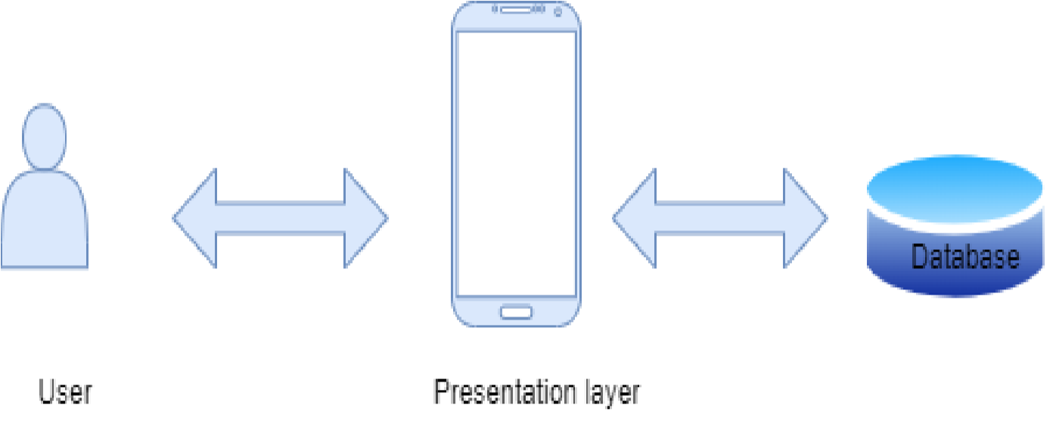
Figure 1. 1 Application Architecture Diagram

1.9. Gantt chart:
A Gantt Chart in MDCAT Application is a timeline-based project management tool that outlines the different phases of development, along with their start and end dates. It helps track progress, allocate tasks, and ensure timely completion of your MDCAT quiz application.

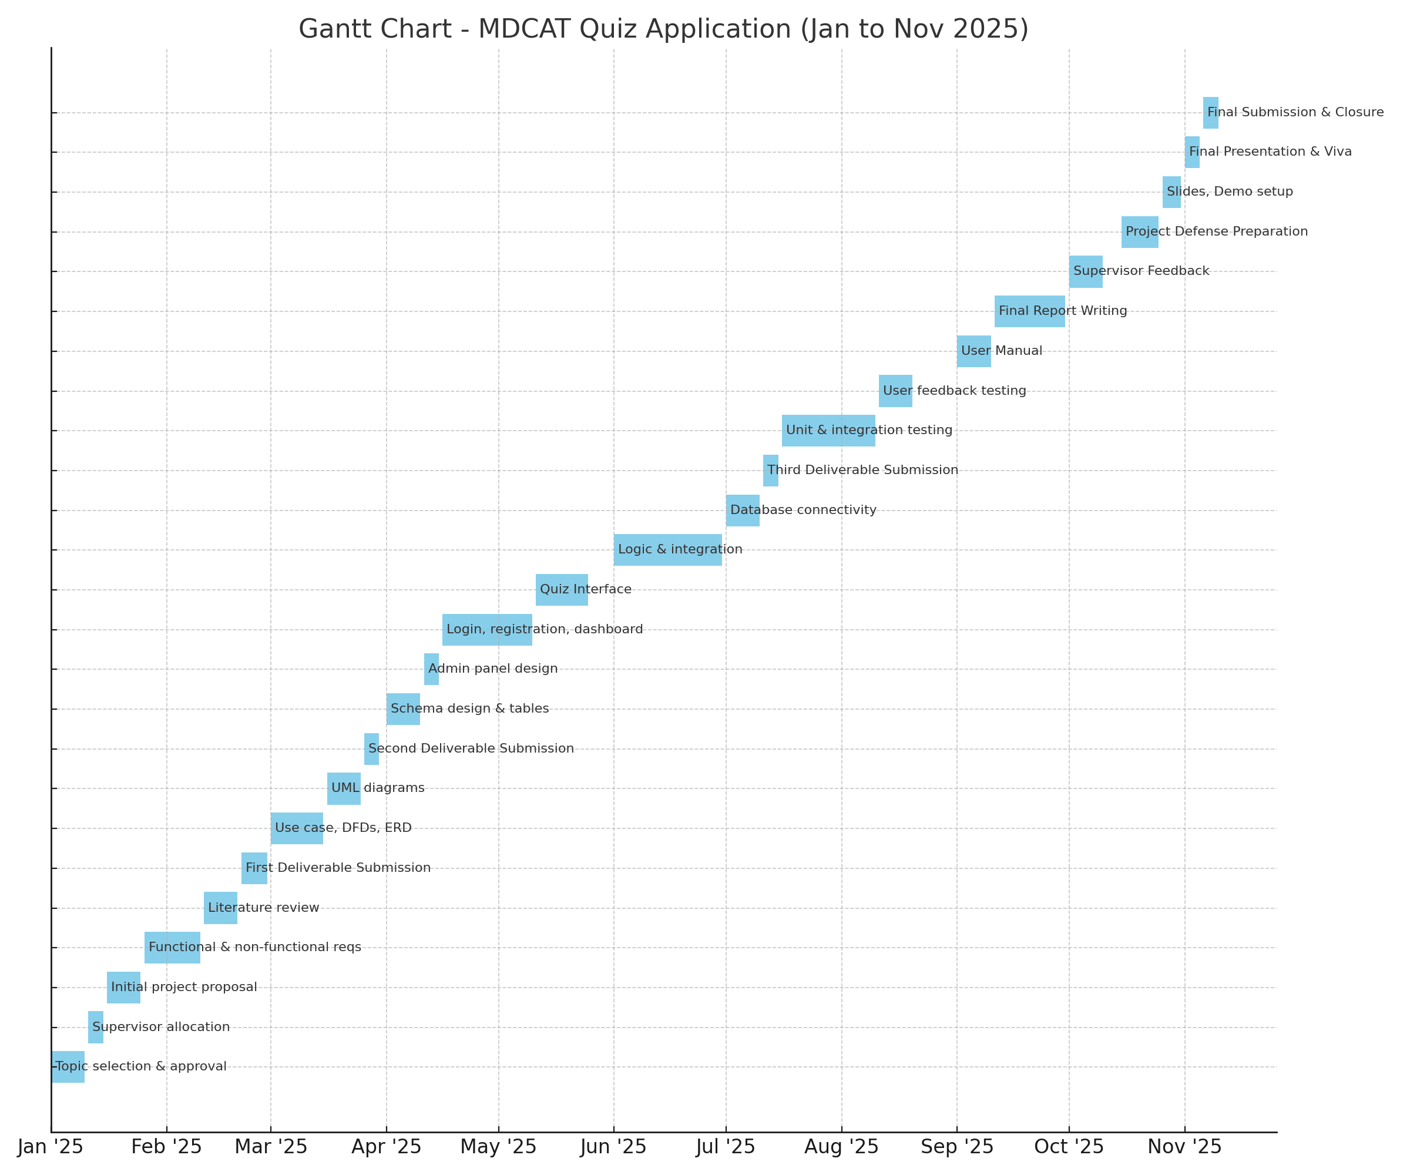

Figure 1.2 Gantt Chart

Hardware Requirements:

Processor: Intel core i5
RAM: 8GB
Storage: 256GB SSD
Display: full HD (1920 x 1080) resolution or higher
Android devices: At least one mid-range android devices
Testing Devices: Smartphones and tablets to test the app on Android.

Software Requirements:

Backend Development: Node.js or Python.
Frontend Development: React Native.
Database: Firebase.
Android Studio: Latest version with React Native and Node.js or Python installed.
Visual Studio Code: Optional, with React Native and Python or Node.js extensions installed.
Web Browsers: Google Chrome, Firefox, Safari (for web-based testing and debugging).
Windows: Windows 10 or later.

1.11. Tools and technologies used with reasoning:

Table 1.1 Tools& Technologies used with reasoning:

Specifications | Required
Used coding language | Node.js, React Native
Hardware | PCs, Laptops
IDE | VS Code or Android Studio
Operating System | Window
Database | Firebase
Documentation and Artefacts | Microsoft Word, PointDraw.io

Chapter 2: First Deliverable

2.1. Introduction:

The MDCAT Quiz Application is designed to help medical students prepare for the Medical and Dental College Admission Test (MDCAT) through interactive quizzes, performance analytics, and adaptive learning. The application will feature subject-wise MCQs, timed quizzes to enhance learning.

2.2. Project/Product Feasibility Report:
The project “MDCAT Quiz Application” may include following feasibilities:
- Technical
- Operational
- Economic
- Schedule
- Specification
- Information
- Motivational
- Legal and Ethical

2.2.1. Technical Feasibility

The application will be developed using modern web and mobile technologies such as React Native (for cross-platform mobile development), Node.js (for backend), and Firebase (for database and authentication). These technologies ensure scalability, security, and ease of maintenance.

2.2.2. Operational Feasibility

This application will be user-friendly and accessible via smartphones, tablets, and web browsers. The intuitive UI/UX design ensures that students can easily navigate the platform. Faculty members may also use it for monitoring student progress.

2.2.3. Economic Feasibility

The project will primarily require development time and hosting costs. By leveraging Firebase’s free tier and open-source technologies, development costs can be minimized. Revenue generation models, such as premium subscriptions and ads, can help sustain the project.

2.2.4. Schedule Feasibility

The project follows a 20-week timeline, covering requirement analysis, design, development, testing, and deployment. The use of Agile methodology ensures iterative development and timely feature releases.

2.2.5. Specification Feasibility

The app must meet specific requirements, including quiz functionality, real-time performance tracking, and secure authentication. The chosen tech stack supports these specifications efficiently.

2.2.6. Information Feasibility

The question bank will be sourced from verified MDCAT preparation materials and medical educators to ensure the accuracy and reliability of the quiz content.

2.2.7. Motivational Feasibility

Students are highly motivated to use digital learning tools, especially for competitive exams. The app will incorporate leaderboards, achievement badges, and AI-based progress tracking to increase engagement.

2.2.8. Legal & Ethical Feasibility

The application must comply with data privacy laws (e.g., GDPR for international users). Questions and study materials will be sourced ethically, ensuring no copyright violations.

2.3. Project/Product Scope

The MDCAT Quiz Application will provide a comprehensive quiz-based learning system with:
- Subject-wise and full-length MDCAT quizzes
- Real-time performance analytics
- Leaderboard & achievements

2.4. Project/Product Costing

2.4.1. Project Cost Estimation By Function Point Analysis

Function points will be calculated based on user inputs, outputs, queries, and data files. Estimated size = 200-300 FP

2.4.2. Project Cost Estimation by using COCOMO’81 (Constructive Cost Model)

Using the Basic COCOMO model:
- Estimated effort = 3.2 * (KLOC)^1.05
- Development time = 2.5 * (Effort)^0.38

2.4.3. Activity Based Costing

Costs will be estimated based on:
- Development time (frontend/backend)
- Hosting & API costs
- Testing & deployment

2.5. Task Dependency Table
A Task Dependency Table is used in a Final Year Project (FYP) to show the relationship between different tasks. It helps in identifying which tasks need to be completed before others can begin. This is especially useful for the first deliverable, which usually includes project proposal, research, and planning.

Table 2. 1 Task Dependency Table:

Task# | Task | Dependencies
T1 | Proposal | T1
T2 | Feasibility Report | T2
T3 | Cost Estimation | T3
T4 | System Specification& Analysis | T3,T4
T5 | Domain model | T5
T6 | Allocate Requirements | T5,T6
T7 | Application Development | T6,T7
T8 | Processing | T7,T8
T9 | Testing | T8,T9
T10 | Showing | T8,T9,T10

2.6. CPM - Critical Path Method
CPM will be used to identify critical tasks that affect project completion time. The longest path in the task dependency graph will determine the project’s duratio
Table 2. 2 CPM:
Task | Duration in days | Activity | Predecessor
T1 | 8 | A | None
T2 | 13 | B | A
T3 | 13 | C | B
T4 | 6 | D | C
T5 | 16 | E | D
T6 | 11 | F | E
T7 | 12 | G | F
T8 | 16 | H | G
T9 | 10 | I | H
T10 | 33 | J | I
T11 | 32 | K | J
T12 | 41 | L | K

A: Activity: Duration
Determining the following six parameters for each activity which can identify the critical path:
ES: earliest start time: the earliest time at which the activity can start given that its precedent activities must be completed first.
ES (K)= max [EF(J) : J is an immediate predecessor of K]

EF: earliest finish time: equal to the earliest start time for the activity plus the time required to complete the activity.
EF (K)= ES (K) + Dur (K)

LF: latest finish time: the latest time at which the activity can be completed without delaying the project.
LF (K)= min [LS(J) : J is a successor of K]

LS: latest start time: equal to the latest finish time minus the time required to complete the activity.
LS (K)= LF(K) – Dur (K)

TS: Total Slack: the time that the completion of an activity can be delayed without delaying the end of the project
TS (K)= LS(K) – ES(K)

FS: Free Slack: the time that an activity can be delayed without delaying both the start of any succeeding activity and the end of the project.
FS (K)= min [ES(J) : J is successor of K] – EF(K)

The slack time for an activity is the time between its earliest and latest start time, or between its earliest and latest finish time. Slack is the amount of time that an activity can be delayed past its earliest start or earliest finish without delaying the project.
The critical path is the path through the project network in which none of the activities have slack, that is, the path for which ES=LS and EF=LF for all activities in the path. A delay in the critical path delays the project. Similarly, to accelerate the project it is necessary to reduce the total time required for the activities in the critical path.

2.6.1 Update CPM Diagram

As the project progresses, the actual task completion times will be known and the network diagram can be updated to include this information. A new critical path may emerge, and structural changes may be made in the network if project requirements change.

D
E
B
A
C
F
G
End
Start

\

Figure 2.1

The critical path is:
A, C, F, G

2.7. Gantt chart
A Gantt Chart in MDCAT Application is a timeline-based project management tool that outlines the different phases of development, along with their start and end dates. It helps track progress, allocate tasks, and ensure timely completion of your MDCAT quiz application.

Figure 2.2

2.8. Introduction to Team member and their skill set

Table 2.3

Name | Roll no | Responsibilities and skills
Nimra | 20BSIT29943 | Documentation, Designing, Good Communication Skills
Khadija | 21BSIT30244 | Problem Solver, Risk Management,
Bisma | 21BSIT30243 | Proof Reading, Manage Budget,

2.9. Task and Member Assignment Table
A table should be formed which consists of a list of tasks and correspondingly allocation of members to that task. The basic aim of this table would be an indication of the amount of work the members would be performing.

Table 2.4
Task ID | Task Description | Duration | Members
T1 | Project Proposal | 8 | Nimra Fatima, Bisma Saeed, Khadija Malik
T2 | Software Specification | 13 | Nimra Fatima, Bisma Saeed, Khadija Malik
T3 | Feasibility Report | 13 | Nimra Fatima, Bisma Saeed, Khadija Malik
T4 | Project Costing | 6 | Nimra Fatima, Bisma Saeed, Khadija Malik
T5 | Requirement Analysis | 16 | Nimra Fatima, Bisma Saeed, Khadija Malik
T6 | Gantt Chart | 11 | Nimra Fatima, Bisma Saeed, Khadija Malik
T7 | Critical Path | 12 | Nimra Fatima, Bisma Saeed, Khadija Malik
T8 | Forms and Table | 16 | Nimra Fatima, Bisma Saeed, Khadija Malik
T9 | Key Function | 10 | Nimra Fatima, Bisma Saeed, Khadija Malik

2.10 Tools and Technologies with Reasoning

Table 2.5

Specifications | Required
Used coding language | Node.js, React Native
Hardware | PCs, Laptops
IDE | VS Code or Android Studio
Operating System | Window
Database | Firebase
Documentation and Artefacts | Microsoft Word, PointDraw.io

2.11. Vision Document
The MDCAT Quiz App aims to enhance medical entrance exam preparation through AI-powered quizzes and personalized learning analytics. The goal is to make MDCAT preparation more engaging and effective.

2.12. Risk List

Table 2.6

Risk | Mitigation strategy
Data loss | Cloud backup
Security breach | Strong encryption
Deadline slippage | Agile methodology
Low user engagement | Gamification features

2.13. Product Features/ Product Decomposition

Core Features:
- Quiz system (timed & untimed)
- Performance tracking
- Leaderboard & Gamification

Advanced Features:
- Mock exam simulation
- Offline mode (if feasible)

Chapter 3: Second Deliverable For Object Oriented Approach

3.1 Introduction:
This chapter provides a detailed specification of the MDCAT quiz application by defining system specifications, external entities, requirements, and use case models. The goal is to establish a structured foundation for the application's development.

3.1.1 Systems Specifications
The system will be a web-based and mobile-compatible application designed to assist MDCAT aspirants in their exam preparation through quizzes, progress tracking, and performance analytics.
Introduction
This clause should contain brief “Introduction” of the system under discussion domain knowledge. It can also contain company, its location, its historical background and its current status in the market. The most important part of this clause is to give an overview of the major business areas of the company. This overview must be very brief so that one can get a bird’s eye view of the organization under study.
Existing System
This clause must be focusing on providing a comprehensive detail of main business areas of the organizations that we have just mentioned in the previous clause. But here the discussion should be more elaborative.

Organizational Chart
Organizational chart will be very much supportive to get a better overview of the organization’s business areas and their decomposition into different departments.
Scope of the System
The Scope may include the boundaries of the system under study. To what domain you want to restrict your project must be clearly mentioned in this clause.

Summary of Requirements: (Initial Requirements)
An abstract is necessary at this stage to give an understanding of the initial requirements of the system. This will show what high level requirements the proposed system must address. This abstract will act as a foundation for the future analysis of the system.

3.1.2. Identifying External Entities

- Students (Users)
- System Administrator
- Question Database
- Reporting System

3.1.3. Context Level Data Flow Diagram:
A high-level DFD will be created to illustrate data flow between external entities and the system.

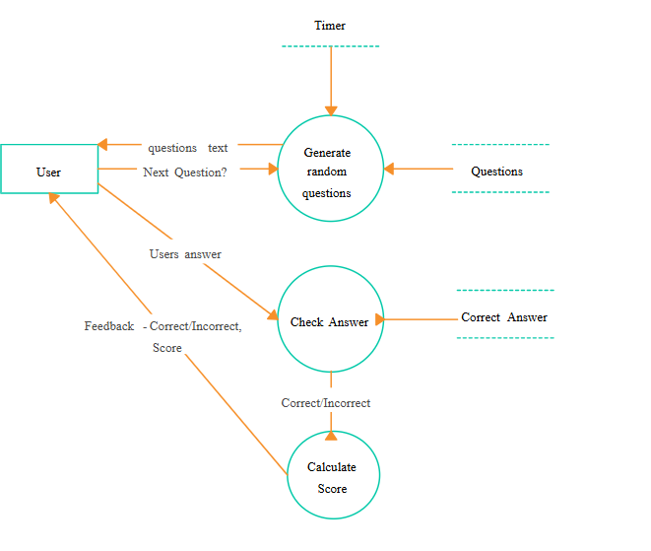
Figure 3. 1 Context Level Data Flow Diagram

3.1.4. Capture "shall" Statements:

Table 3. 1 Capture “shall” Statements
1 | The system shall provide users with subject-wise and full-length mock quizzes.
2 | The system shall track user progress and performance.
3 | The system shall maintain a question bank with difficulty levels.
4 | The system shall generate reports based on user performance.

3.1.5 Analysis level Use Case Diagram:

3.1.5.1 UCI Register:
The customer/service provider shall be able to register application.

Table 3. 2 Describes Register user detailed use case

Use Case ID | UC-1
Use Case Name | Register User
Actors | Student (Primary), System (Secondary)
Description | Allow user to register account
Trigger | ……………
Pre-conditions | The user must have internet connectivity
Post-conditions | The user shall be able to create account
Normal flow | 1: User shall enter details name, username, email and password.  2: User then register himself in a system.
Flow alternative | Error message will be displayed for entering wrong details.
Exceptions | No internet connection
Assumptions | 1: User must have internet connection.  2: User shall enter correct information.

3.1.5.2 UC-2: Login:
The customer/service provider shall be able to login to application.

Table 3. 3 Describes login detailed

Use Case ID | UC-2
Use Case Name | Login
Actors | Student (Primary), System (Secondary)
Description | Allow user to login
Trigger | User enter a wrong password
Pre-conditions | The user must have to firstly register in the system
Post-conditions | User shall be able to login the system
Normal flow | User shall enter credentials email and password
Flow alternative | Error message will be displayed for entering wrong credentials
Exceptions | No internet connection
Assumptions | 1: User must have internet connection.  2: User shall enter correct information.

3.1.5.3 UC-3: Subject wise quiz attempt:
Students should select a subject (e.g., Biology, Chemistry) and take quizzes.

Table 3.4 Describes Detailed Subject wise quiz attempt

 | UC-3
  Use Case ID
Use Case Name | Take Subject-wise Quiz
Actors | Student (Primary), System (Secondary)
Description | This use case describes how a student selects a subject and takes a multiple-choice quiz within the app. The system presents questions, tracks time, and evaluates the score.
Trigger | Student selects a subject and clicks on the "Start Quiz" button.
Pre-conditions | 1: Student is logged in  2:Quiz questions are available for the selected subject.
Post-conditions | 1: Quiz is submitted and evaluated.  2:Results and explanations are displayed.  3:Score is saved to user’s quiz history.
Normal flow | 1: Student logs in to the app.  2: Student selects a subject (e.g., Biology).  3: Student clicks "Start Quiz".  4: Quiz timer starts.  5: Student submits the quiz or timer runs out.
Flow alternative | Student exits quiz before completing.  Quiz submitted before timer ends.
Exceptions | Question bank is empty for selected subject.  No internet connection.
Assumptions | 1: User must have internet connection.  2: User shall enter correct information.

3.1.5.4 UC-4 Timer for Quizzes:

Table 3.5 Describes Detailed Timer for quizzes

 | UC-4
  Use Case ID
Use Case Name | Timer for Quizzes
Actors | Student (Primary), System (Secondary)
Description | The system sets a countdown timer when a quiz begins.  The student must complete and submit answers before time runs out.  If the timer expires, the system auto-submits the quiz.
Trigger | Student clicks "Start Quiz".
Pre-conditions | Student is logged in.  Quiz is initialized with selected questions.  Timer duration is defined based on quiz type (e.g., full MDCAT or topic-wise).
Post-conditions | Quiz is submitted either manually by the student or automatically when the timer ends.  Score is calculated and shown.
Normal flow | 1:Student selects a quiz and clicks “Start Quiz”.  2:System initializes a timer (e.g., 60 minutes for 100 questions).  3:Timer is displayed on the quiz screen. Timer counts down while the student answers questions.
Flow alternative | Student finishes early  Pause timer not allowed
Exceptions | System clock is manipulated or paused  App crashes or reloads mid-quiz
Assumptions | Timer starts only after question is loaded.  User cannot pause or extend the timer manually.

3.1.5.5 UC-5 Secure Authentication:

Table 3.6 Describes Detailed Secure authentication

 | UC-5
  Use Case
Use Case Name | Score Authentication
Actors | Student (Primary), Admin (Primary), System (Secondary)
Description | Allows users to securely log in to the app using encrypted credentials. Ensures only authorized users access the platform.
Trigger | User submits login credentials.
Pre-conditions | User is registered with a valid email and password.  Credentials are stored securely.
Post-conditions | User is authenticated and granted access to app features.  Session or token is created.
Normal flow | 1: If valid:  System creates an auth token (e.g., JWT) or session ID User is logged in and redirected to dashboard.  2: If invalid:  System shows error message: Invalid credentials.
Flow alternative | User requests "Remember Me".  Two-Factor Authentication.
Exceptions | try again later.  Lock account or show CAPTCHA after 3-5 failed attempts.
Assumptions | Passwords are stored using strong hashing. All communications use HTTPS.

3.1.5.6 UC-6 Logout:

Table 3.7 Describes Detailed Logout

Use Case ID | UC-6
Use Case Name | Logout
Actors | Student , Admin
Description | Allows a logged-in user (student or admin) to securely log out of the application, ending their session and clearing authentication tokens
Trigger | User clicks the "Logout" button or link.
Pre-conditions | User is logged in and has a valid active session/token.
Post-conditions | User is redirected to the login.  Access to authenticated features is revoked.
Normal flow | User clicks on the “Logout” button from the navigation bar or settings.
Flow alternative | Auto Logout
Exceptions | Logout request fails due to network error
Assumptions | Logout is accessible on all authenticated pages.

Use Case Diagram:
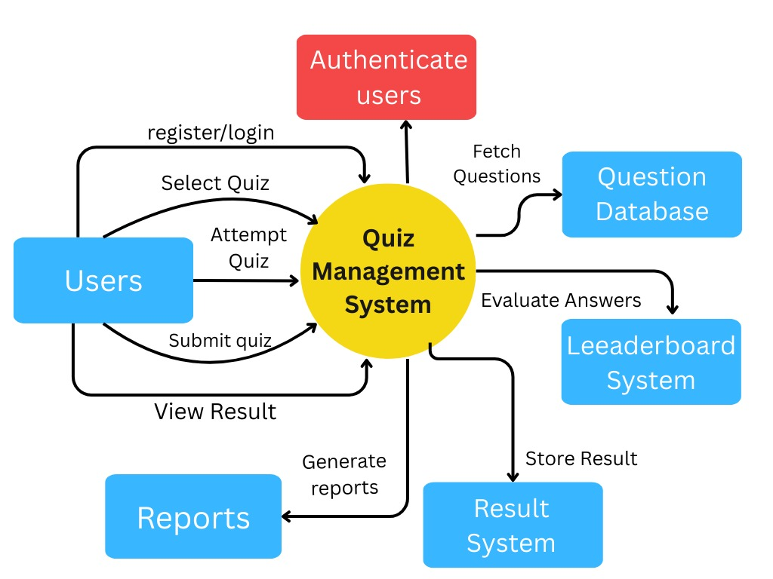
Figure 3.2 Use Case Diagram

Chapter 4: Third Deliverable For Object Oriented Approach

4.1. Introduction:
Third deliverable is all about the software design. In the previous deliverable, analysis of the system is completed. Therefore, we understand the current situation of the problem domain. Now we are ready to strive for a solution for the problem domain by using object-oriented approach. Following artifacts must be included in the third deliverable
- Purpose of the document
- Scope of the MDCAT Quiz App
- Brief description of system goals
- Intended audience

4.2. Domain Model:
Domain models represent the set of requirements that are common to systems within a product line. There may be many domains, or areas of expertise, represented in a single product line and a single domain may span multiple product lines.
- Identify core objects: User, Quiz, Question, Result, Subject
- Show object relationships (aggregation, association)
- Include a class diagram showing domain entities and their attributes

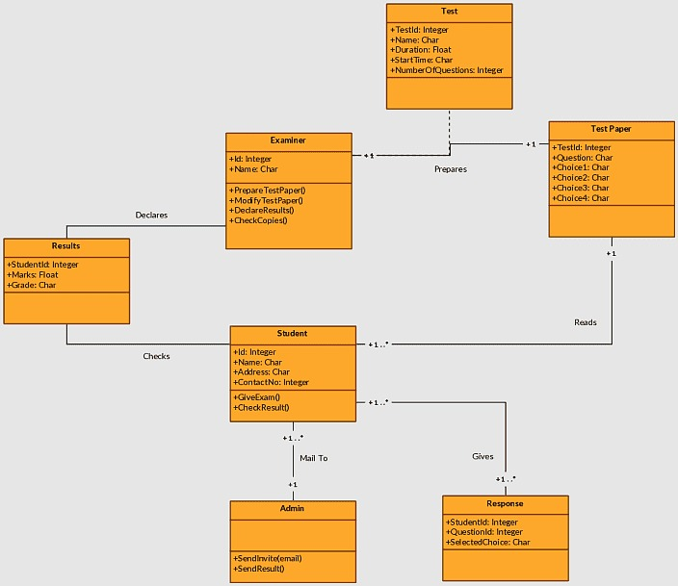
Figure 4. 1 Domain Model diagram

4.3. System Sequence Diagram:

System sequence diagrams are a timeline drawing of an expanded use case.
Quizzes are related by time with the top events occurring first. These quizzes cause the system response. Use case text may be placed on the left side of the system sequence diagram if desired. If this is done, it is best if the use case information lines up with the events in the system sequence diagram.
1: Diagram for a major use case (e.g., "Take Quiz)
2: Show interaction between external actor and system boundary
3: Include messages: input, validation, result generation

Diagram:
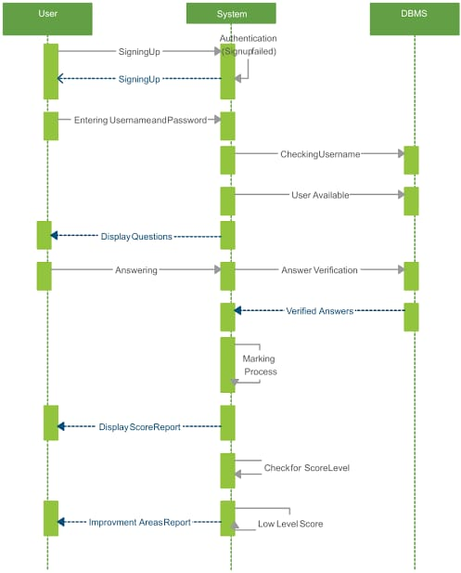
Figure 4. 2 System Sequence Diagram

4.4. Sequence Diagram:
Interaction diagram showing object lifelines and message flow Importance in dynamic modeling.
- The order of messages exchanged between objects.
- The lifelines of objects (how long they exist during an interaction).
- The control flow from actor (e.g., Student) to system components (e.g., Quiz Controller, Question Bank).

Diagram:

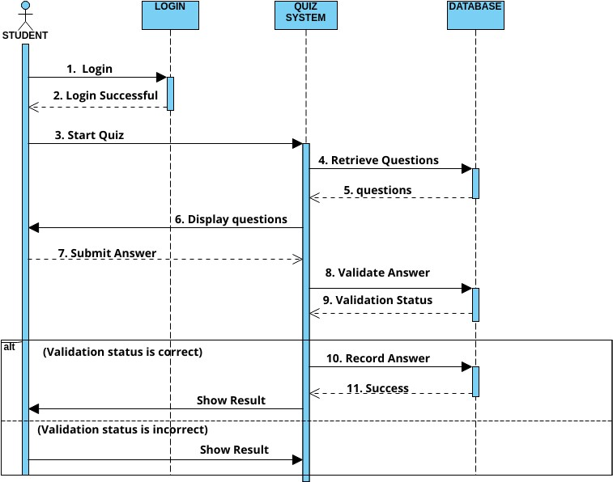 Figure 4.3 Sequence Diagram

4.5. Collaboration Diagram:
A collaboration diagram (also called a communication diagram) shows:
- Objects (instances of classes)
- Links between objects (associations)
- Messages passed between them, numbered to show sequence
A collaboration diagram focuses on the roles and relationships of objects involved in completing a use case.
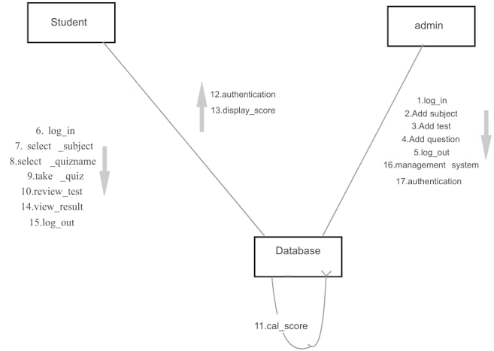
Figure 4.4 Collaboration Diagram

4.6. Operation Contracts:
In the third deliverable of your MDCAT Quiz Application, operation contracts describe the behavior of system operations in terms of:
- What must be true before the operation executes (pre-conditions), and
- What will be true after the operation completes (post conditions).
They help bridge use cases with design, ensuring system logic is correct, predictable, and aligned with business rules.
1. Operation: Register User():
- Responsibility: Create a new user account
- Preconditions: The entered email is not already registered
- Postconditions: A new user object is created and stored in the user database
2. Operation: Login User():
- Responsibility: Authenticate user credentials and start session
- Preconditions: User email and password are correct
- Postconditions: User session is created and token is generated

3. Operation: Start Quiz():
- Responsibility: Begin a quiz session for the selected subject
- Preconditions: User is logged in; quiz is available and not already attempted
- Postconditions: Quiz state changes to "in progress"; questions are fetched and timer starts
4. Operation: Submit Quiz():
- Responsibility: Process answers, calculate score, and store result
- Preconditions: Quiz is in progress and time hasn’t expired
- Postconditions: Score is calculated; result is saved in the database; quiz marked as completed
5. Operation: View Result():
- Responsibility: Retrieve and display the user's result
- Preconditions: User is logged in and has completed at least one quiz
- Postconditions: The quiz result is fetched and shown to the user

4.7. Design Class Diagram:

A Design Class Diagram (DCD) is a detailed version of a class diagram used in the object-oriented approach during the design phase of software development. It describes how different classes interact with each other and what attributes and operations (methods) they have.

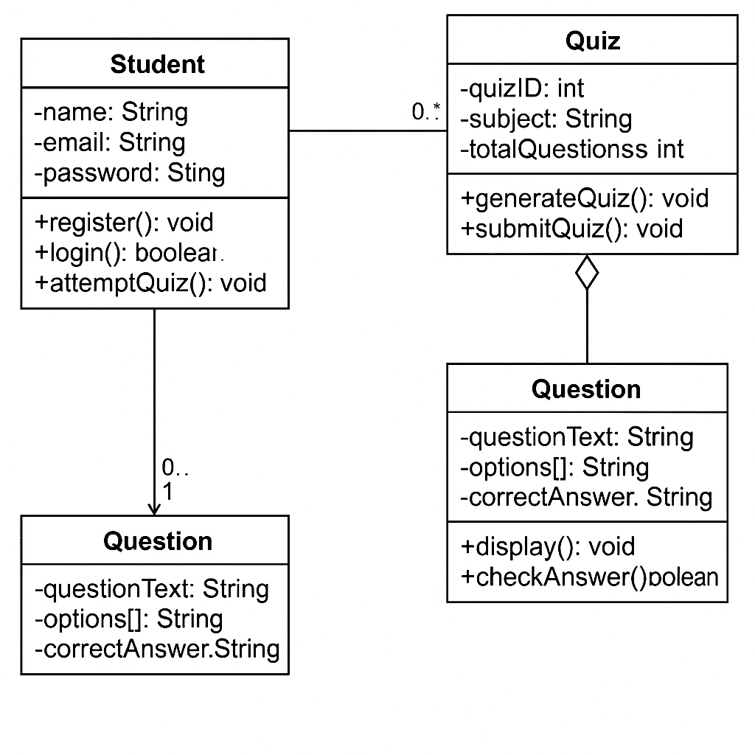
Figure 4.5 Design Class Diagram

4.8. State chart diagram:
A state chart diagram (also known as a state machine diagram) is used to model the dynamic behavior of an object based on its state changes over time in response to events.
It is a key part of object-oriented analysis and design and helps you visualize how the system or objects behave under different conditions.
In the MDCAT Quiz App, a state chart diagram is used to:
- Model how objects like Quiz, User Session, or Result move between different states.
- Clarify the lifecycle of a quiz: from creation to completion.
- Show events (e.g., “submit quiz”, “timeout”) that trigger transitions.
- Help in defining the logic for validations, errors, or state-dependent behavior.

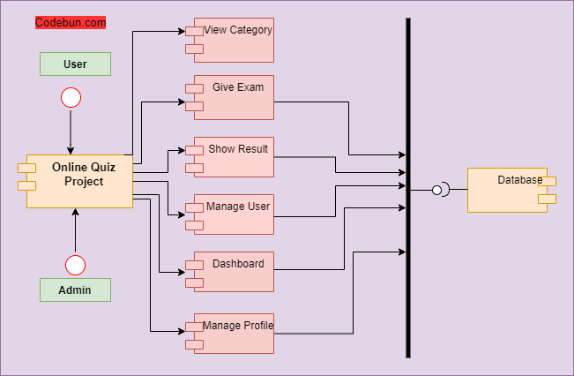

Figure 4.6 State Chart Diagram

4.9. Data Model:
A data model represents the structure of the data your system will store, manipulate, and retrieve. It defines how different entities (like users, quizzes, questions, results) relate to each other in a database.
The data model is crucial for:
- Ensuring data consistency
- Supporting functional requirements like user registration, quiz attempts, result calculation, etc.

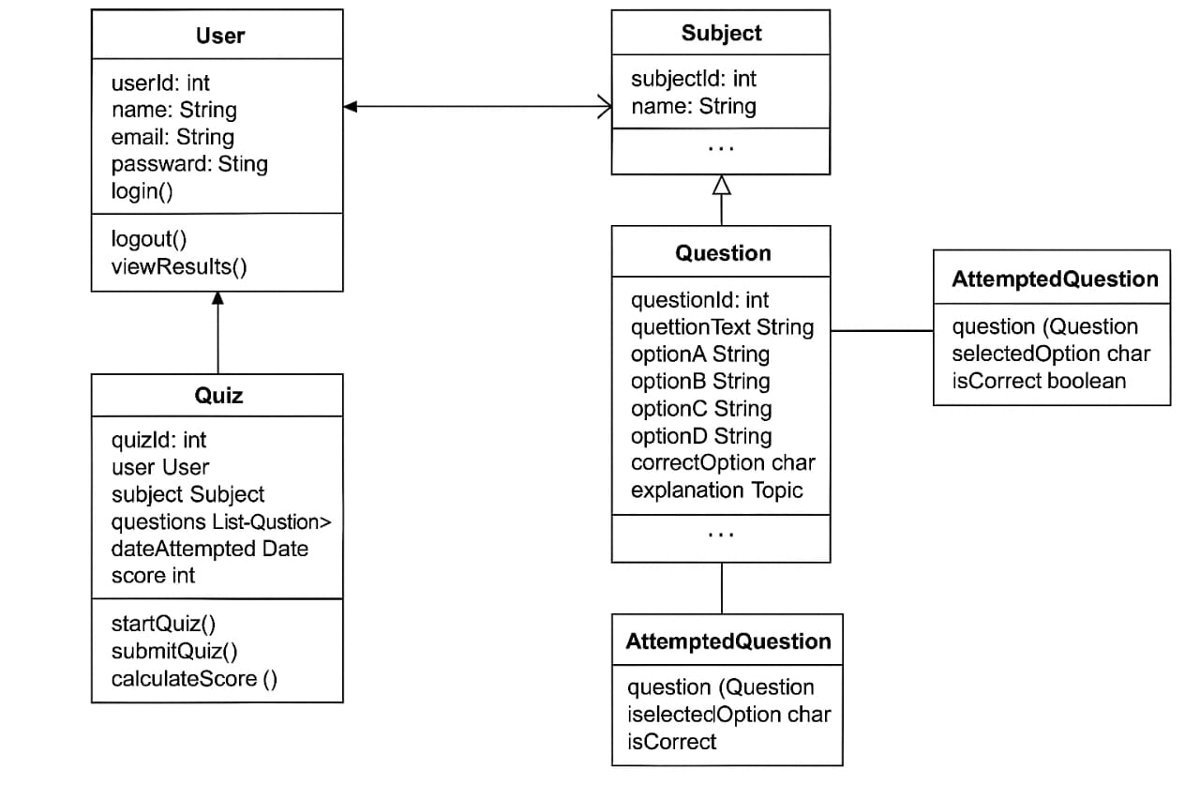
Figure 4.7 Data Model

Chapter 5: 2nd & 3rd Deliverable For structured Approach

5.1. Introduction:
This chapter is part of the official documentation for the MDCAT Quiz Application, which you are currently writing. It covers the 2nd and 3rd deliverables using the Structured Approach. This chapter provides system design techniques such as DFDs, ERDs, pseudocode, structured coding, and testing strategies—all essential for building a robust and maintainable application tailored for MDCAT students.

5.2. Entity Relationship Diagram:

Entities:
Student, Admin, Quiz, Question, Result, Feedback
Relationships:
One Student can have many Results
One Quiz contains many Questions
Admin manages Students and Quizzes
Diagram: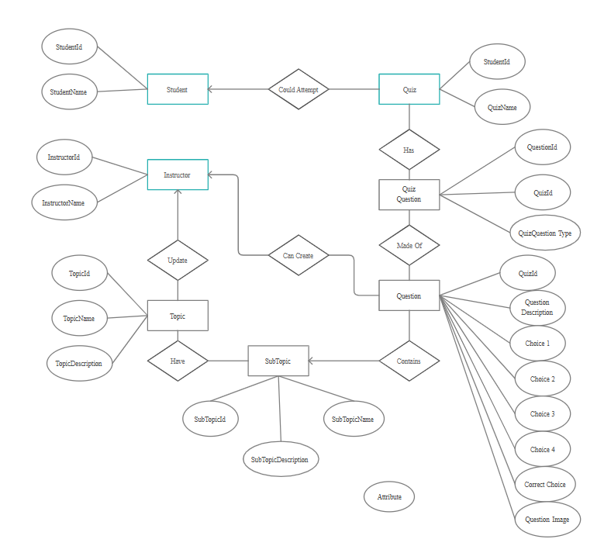

Figure 5.1 Entity Relationship Diagram

5.3. Data flow diagram (Functional Model):

A Data Flow Diagram (DFD) visually represents the flow of information through the MDCAT Quiz Application. It shows how data enters, moves through, and exits the system. It helps identify the inputs, processes, outputs, and data stores involved DFD - level 0

5.3.1. DFD- Level 0:

A Level 0 Data Flow Diagram (DFD) — also called a Context Diagram — gives a high-level overview of how data flows into, through, and out of the MDCAT Quiz App. It treats the entire application as a single process and shows its interaction with external entities.
Purpose of Level 0 DFD:
- To define system boundaries
- To identify external actors
- To describe main data exchanges
External Entities:
Student, Admin, Question Bank, Report System.
Diagram:
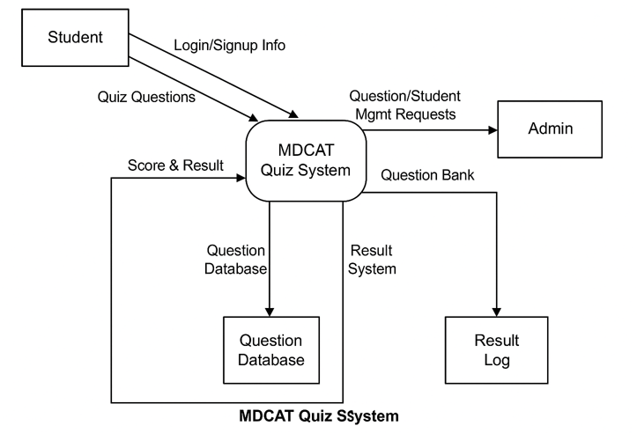
Figure 5.2 DFD – level 0

3.5.2 DFD Level 1:
A Level 1 Data Flow Diagram (DFD) provides a more detailed view of the system compared to Level 0. It breaks down the main process (the entire MDCAT Quiz System) into sub-processes and shows the data flow between them, along with the external entities and data stores.

External Entity:
Student, Admin, Report System

Diagram:

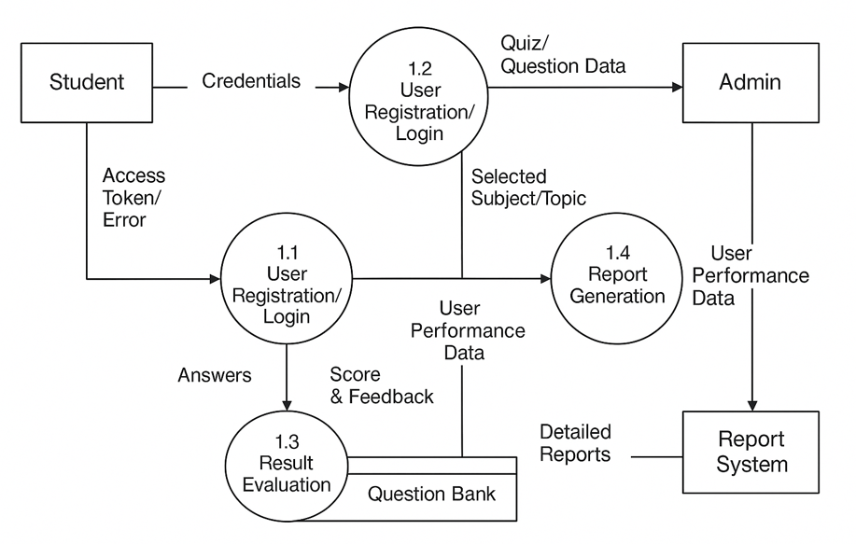

Figure 5.3 DFD - level 1

3.5.3 DFD Level 2 Diagram:
A Level 2 Data Flow Diagram (DFD) provides an even more detailed breakdown of one process from Level 1. It shows how a single module works internally—its sub-processes, data stores, and data f

External Entity:
Student Interacts with all sub-processes.
Diagram:

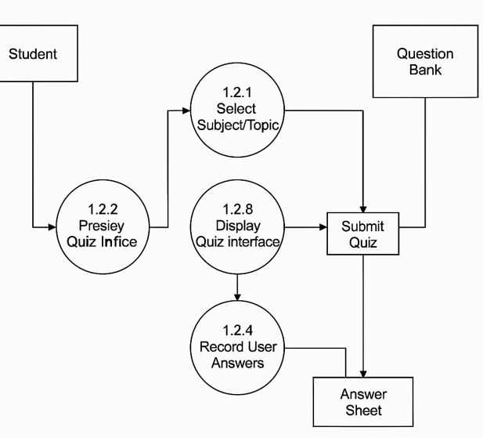

Figure 5.4 DFD - level 2

5.4. State Transition Diagram:

A State Transition Diagram for the MDCAT Quiz App shows how the system changes states based on user actions or events. It helps in understanding how users and the system interact during different scenarios.

State Transition Diagram for MDCAT Quiz Application:

- Start
➝ Initial state when the app is launched.
- Login/Register
➝ User logs in or registers.
  - Event: User enters credentials
  - Transition: Valid credentials → Dashboard
Invalid → Error State
- Dashboard
➝ Displays available quiz categories, profile, and reports.
- Select Quiz
➝ User selects a quiz category or subject.
- Attempt Quiz
➝ Questions are displayed one by one.
  - Event: User selects answers and clicks "Next"
- Submit Quiz
➝ User finishes and submits the quiz.
  - Transition: Answers sent for evaluation
- View Result
➝ User sees performance report/score.
- Logout/Exit
➝ Ends the session and returns to the start state.

Diagram:
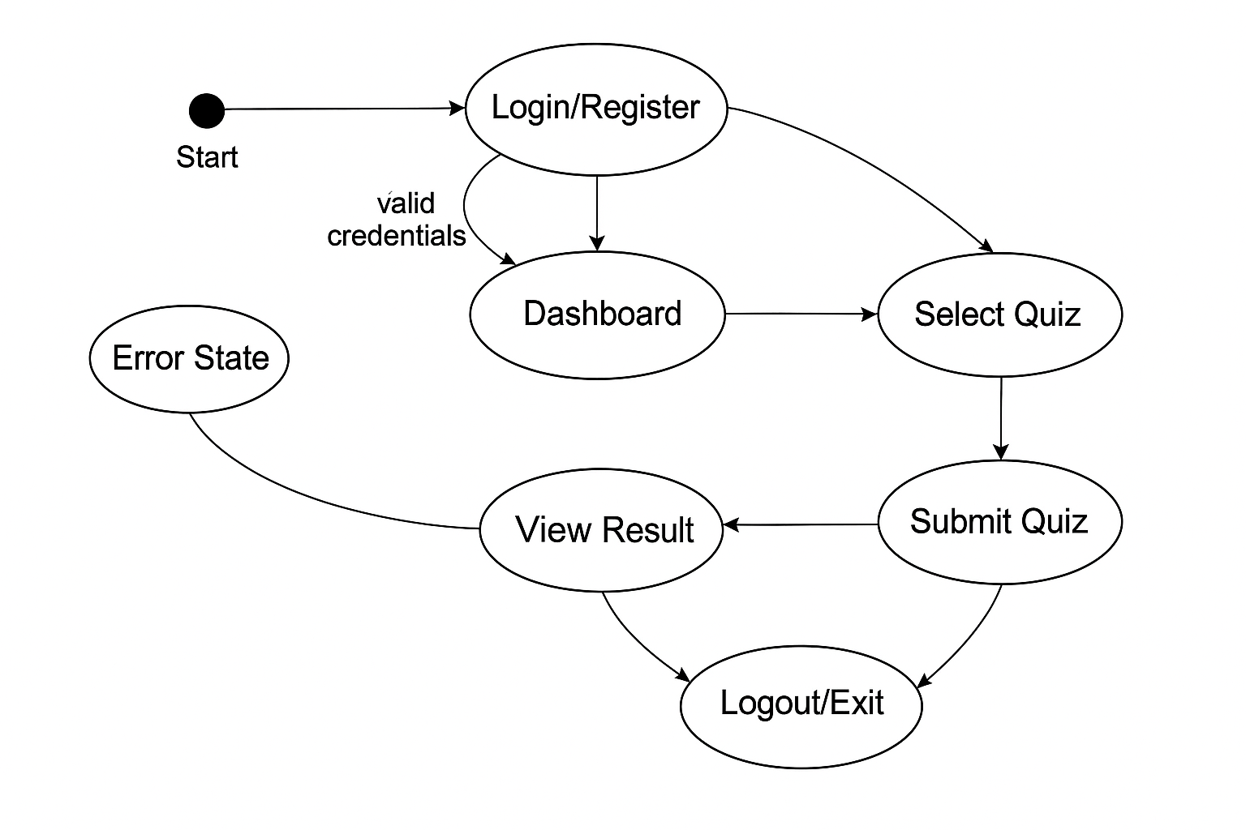

Figure 5.5 State Transition Diagram

5.5. Component Level Design:

Component Level Design is the stage in software design where the internal structure of each software module (component) is specified. It focuses on how the functions, logic, and data inside each component work and interact with other components.

Diagram:

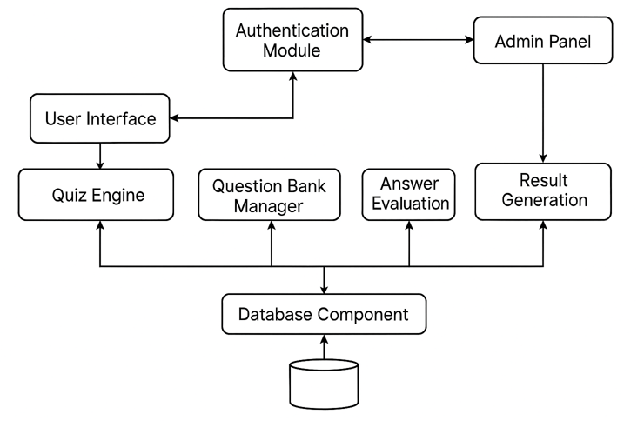

Figure 5.6 Component Level Design

